* **Create Virtual Environment:**
  + **Command:** python -m venv venv
  + **Activate Virtual Environment:**
    - Follow this series of command
    - cd venv
    - cd Scripts
    - ./activate.ps1
* **Django Setup:**
  + pip install django
  + django-admin startproject [give_a_project_name]
  + cd [project_name_that_you_gave]
  + **Then create a Django Web App**

**Command**: python manage.py startapp [give_an_app_name]

* + **Then in settings**.py in main project folder in

INSTALLED_APPS add Your_app_name

e.g

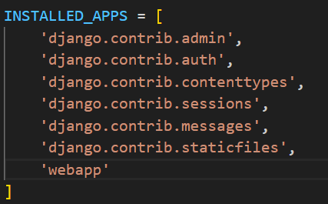

* + Then add a urls.py file in web app folder
  + Then in urls.py of main project folder do following settings

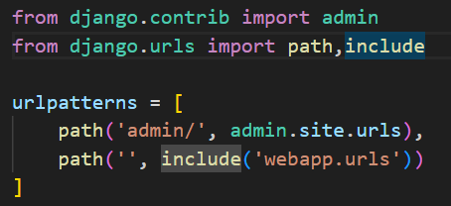

* + Then to check project
  + Make an api in views.py

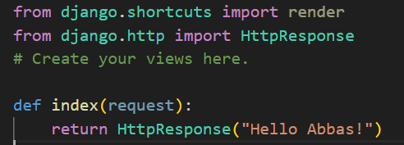

* + Then in urls.py of web app folder do the following settings

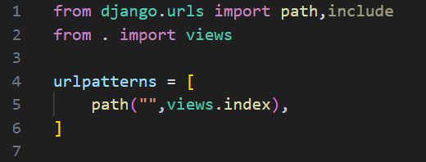

* **To register/update any model in Django**

**Command:**

* + python manage.py makemigrations
  + python manage.py migrate
* **To create a super user to see and manage database**
  + **Command:** python manage.py createsuperuser

Then do the settings as directed by the command itself

* **To display models in admin panel of super user register the model in admins.py file**

